
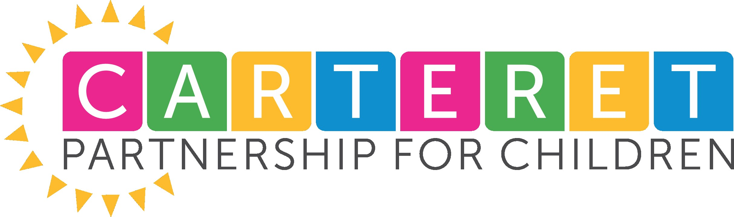
Real Men Read Initiative Registration
Carteret Partnership for Children’s Real Men Read Initiative is a volunteer-driven program that brings male MENtors from the community into preschool classrooms to read four different books throughout the school year.
MENtors hand out free books at the beginning of each visit to eager students who then gather in a circle to follow along with the story and excitedly interact with the reader by sharing questions, guessing what will happen next in the story, and doing activities to help bring the book to life. At the end of the story, the children take the book home to add to their home libraries and share it with their families. The teacher also gets a copy of the book to add to their classroom library.
Carteret Partnership for Children’s Real Men Read program encourages men from the
community to read to children in the classroom 4 times per year
Books and Suggested Reading Schedule
(Actual reading schedule is decided by teacher and volunteer)
Sept/Oct- Book 1
Jan/Feb-Book 2
March/April-Book 3
May/June-Book 4
- Provides positive male role models who value education.
- Models the importance of reading.
- Uses literate opportunity to focus on careers and fulfilling your potential.
- Provides each student with high-quality books to encourage reading at home.
Because men are often seen as less involved in early education, sharing books with a male role model allows all children to connect to reading in a special way.
I am interested in my classroom participating in
Carteret Partnership for Children’s Real Men Read Initiative
*Priority will be given to teachers who have not participated in the past
Name________________________________________________________________________
School______________________________ I have participated in Real Men Read before: Yes/No
Number of children in classroom __________________________________________________
Email _________________________________________________________________________
Phone number _________________________________________________________________
Best way to contact Email _______ Phone_________ Text_____________
Do you need help finding a MENtor? Yes______ No, I know someone___________
I agree to provide CPC with photos from Real Men Read reading program ______ Yes
Please email registration to Tara Willeford at twilleford@carteretkids.org
*Continuation of Initiative will depend upon funding and supply of books

